Homework 5

Assigned: October 8, 2024 (Wednesday)
Due: October 15, 2024 (Wednesday)

Problem 1: Multiway Search Trees (4 Marks)

- Perform In-order Traversal on following multiway search tree implemented with unknown comparator.
- Write pseudocode for In-order Traversal for multiway search tree of order k.

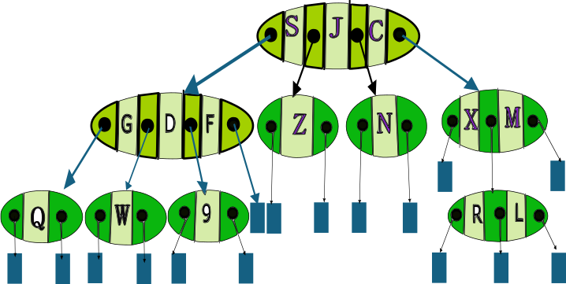

Problem 2: AVL Trees (4 Marks)
- Insert following items (in provided sequence )
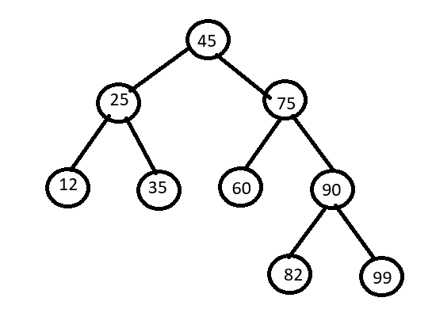
In shown AVL trees. Show AVL tree after each insertion.
16, 108, 87, 89
- Remove element 35 from the AVL tree.
Show Tree after Removal.

Problem 3: 2-4 Trees (4 Marks)
- Write a pseudo code to find In-order successor in 2-4 tree.
- Write a pseudo code to find in-order predecessor in 2-4 tree.

